In the first step, you would need to select the card(either you can select eCards or Print-At-Home Cards)
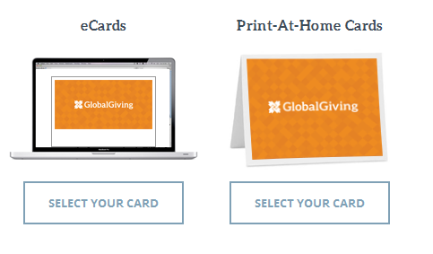
=============================================================

Flow for eCards

- Follow below Steps only if you select “eCards”

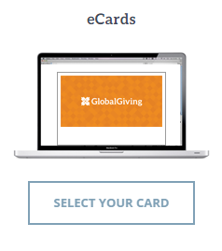

eCards is a digital version of a greetings card, typically accessed by the recipient via a hyperlink in an email.
Print-At-Home-Cards is a card which can Create and print cards from your home computer, on your printer, for any occasion anytime you wish!

2) The moment you click on “eCards”,you will be redirected to a next page where it is required to Pick up your favorite design as shown below

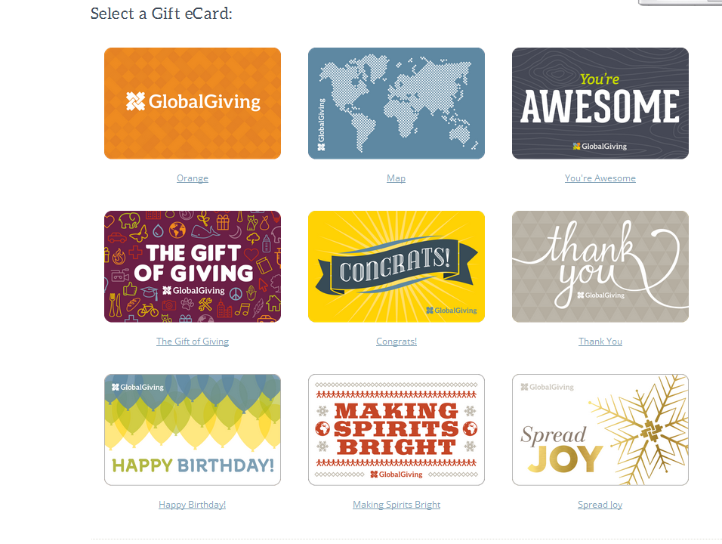

- After selecting your favorite design, it will go to “card to send page” where you need to fill up below details.

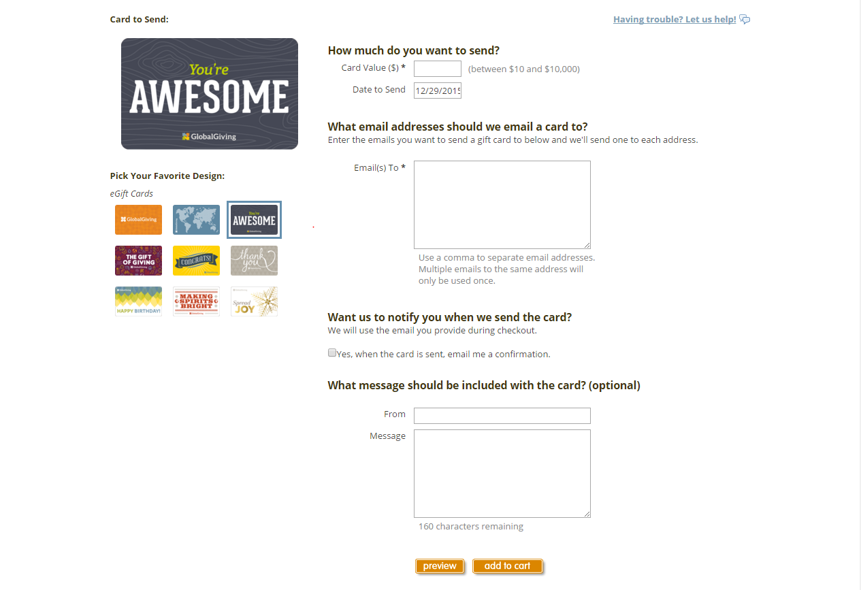
4

- Even here you have option to change your design where you can pick up one more design without going to the previous page then after filling above details,it will go to the following page

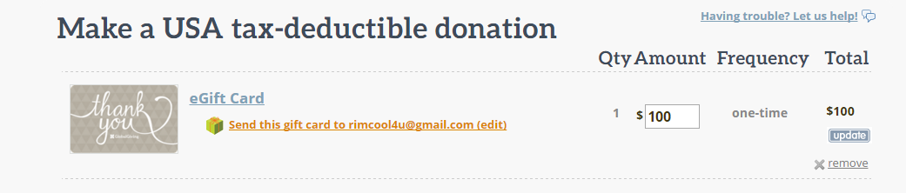

- Now it will go to the payment gateway page,proceed with the payment to complete the process.

- Once you complete your donation/payment, We'll send your card via Email to whom your dedicating this card and recipient can login to their Email ID and can download the card which has your message on it.

==============================================================================

Flow for Print-At-Home Cards

- Follow below Steps only if you select “Print-At-Home Cards”
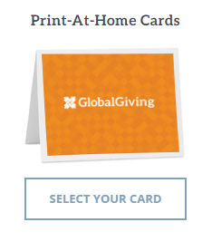

- The moment you click on “Print-At-Home Cards”,you will be redirected to a next page where it is required to Pick up your favorite design as shown below

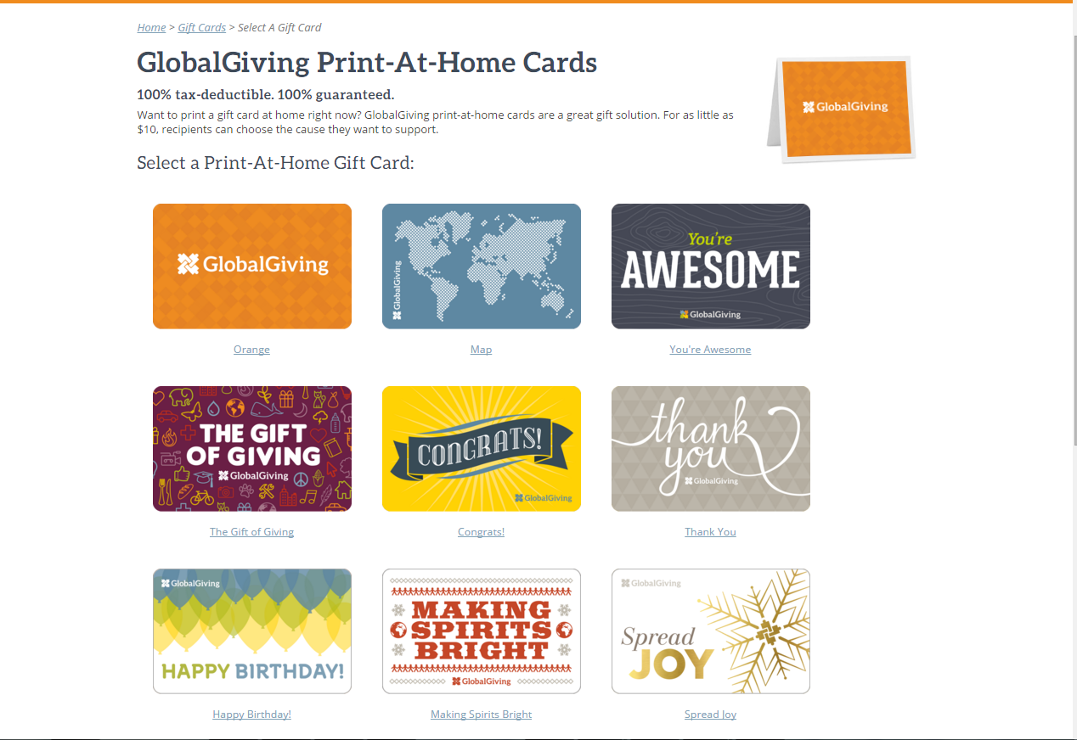

- After selecting your favorite design, it will go to “card to send page” where you need to fill up below details.

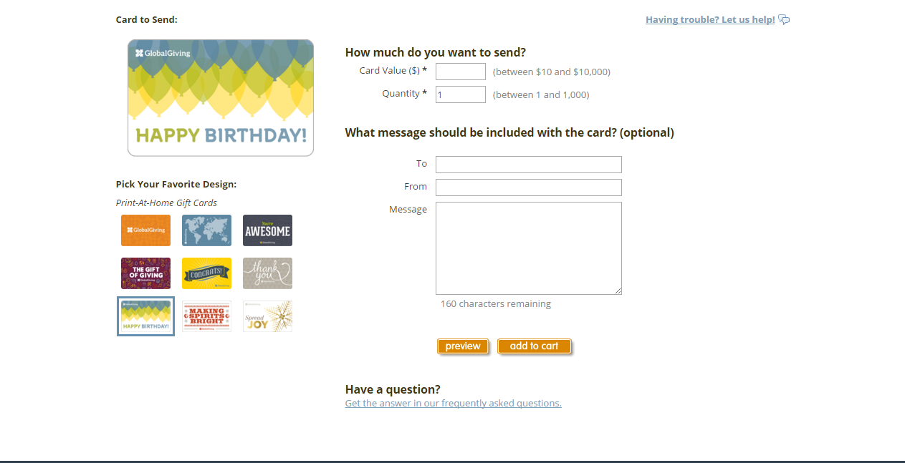

- Even here you have option to change your design where you can pick up one more design without going to the previous page then after filling above details ,it will hit payment gateway page,proceed with the payment to complete the process.

- Once you complete your donation/payment, recepient can print the cards from their home computer.

- First select the card as shown in the step 1)
- You will be redicted to next page where you need to select the design of the card shown in the step 2)
- After selecting your favorite design, it will go to “card to send page” where you need to fill up the details shown in the step 3)
- Even here you have option to change your design where you can change your design without going to the previous page then fill remaining details shown in the step 4)
- Now it will go to the payment gateway page,proceed with the payment to complete the process shown in the step 5)
- We will send your card via method you select shown in the step 6)

